API Gateway & Microservices Documentation

1. Introduction
This academic report documents the development of a distributed microservices architecture built using the NestJS framework.
The system consists of two independent microservices:

1. Authentication Microservice
2. Movies Microservice

These microservices are connected through a central API Gateway that acts as a unified entry point for all external client requests.

The purpose of this architecture is to achieve modularity, scalability, loose coupling, and maintainability—features commonly required in real-world enterprise systems.

2. System Architecture Overview
The project follows a microservices‑based architecture, where each service runs independently but communicates via HTTP through the API Gateway.

ARCHITECTURE DIAGRAM (Text Representation):

CLIENT (Frontend / Postman)
|
↓
API GATEWAY (Port 3000)
|
---------------------------------
| |
AUTH SERVICE (Port 3001) MOVIES SERVICE (Port 3001)
| |
MongoDB (Users Collection) MongoDB (Movies Collection)

The API Gateway manages:
- Routing incoming requests
- Delegating requests to relevant services
- Ensuring a unified access layer
- Reducing coupling between clients and microservices

3. Technologies Used
• NestJS – Backend framework used for both microservices and gateway
• MongoDB Atlas – Cloud NoSQL database
• Mongoose – ODM used for schema and database interaction
• JWT (JSON Web Tokens) – Used for secure authentication
• Postman – Used for API testing
• Node.js – Environment to run NestJS services

4. Authentication Microservice
The Authentication Microservice is responsible for:
- User registration
- Password hashing
- Login authentication
- JWT token generation

Base URL:
http://localhost:3001/auth

Database Collection:
• users

The microservice implements secure password hashing and token-based authentication following web security best practices.

5. Movies Microservice
The Movies Microservice implements all CRUD (Create, Read, Update, Delete) operations for movie data.
It is protected by JWT authentication, meaning users must be logged in to access any movie endpoint.

Base URL:
http://localhost:3001/movies

Features:
- Add a new movie
- Retrieve all movies
- Retrieve a movie by ID
- Update movie details
- Delete a movie

6. API Gateway
The API Gateway is implemented using NestJS and serves as the single entry point for all communication between clients and microservices.

Base URL:
http://localhost:3000

Purpose of the API Gateway:
• Centralized routing
• Single public API endpoint
• Isolation between clients and internal services
• Easier maintenance and scaling
• Hiding microservices’ internal structure from clients

Routing Rules:
- /auth → forwarded to Authentication Service
- /movies → forwarded to Movies Service

This ensures consistency, improved security, and simplified client-side integration.

7. API Endpoints Documentation
AUTHENTICATION ENDPOINTS (Through Gateway)
-----------------------------------------

POST /auth/signup
Request Body:
{
"name": "Test User",
"email": "test@example.com",
"password": "123456",
"location": "Egypt"
}

POST /auth/login
Response:
{
"access_token": "<JWT_TOKEN>"
}

MOVIES ENDPOINTS (Through Gateway)
----------------------------------
POST /movies
GET /movies
GET /movies/:id
PATCH /movies/:id
DELETE /movies/:id

All movie endpoints require:
Authorization: Bearer <JWT_TOKEN>

8. Postman Testing Workflow
1. Send POST request to /auth/signup
2. Send POST request to /auth/login
3. Copy the access_token returned in the response
4. Add the token to Postman → Authorization → Bearer Token
5. Test all /movies endpoints through the gateway
6. Verify successful CRUD operations
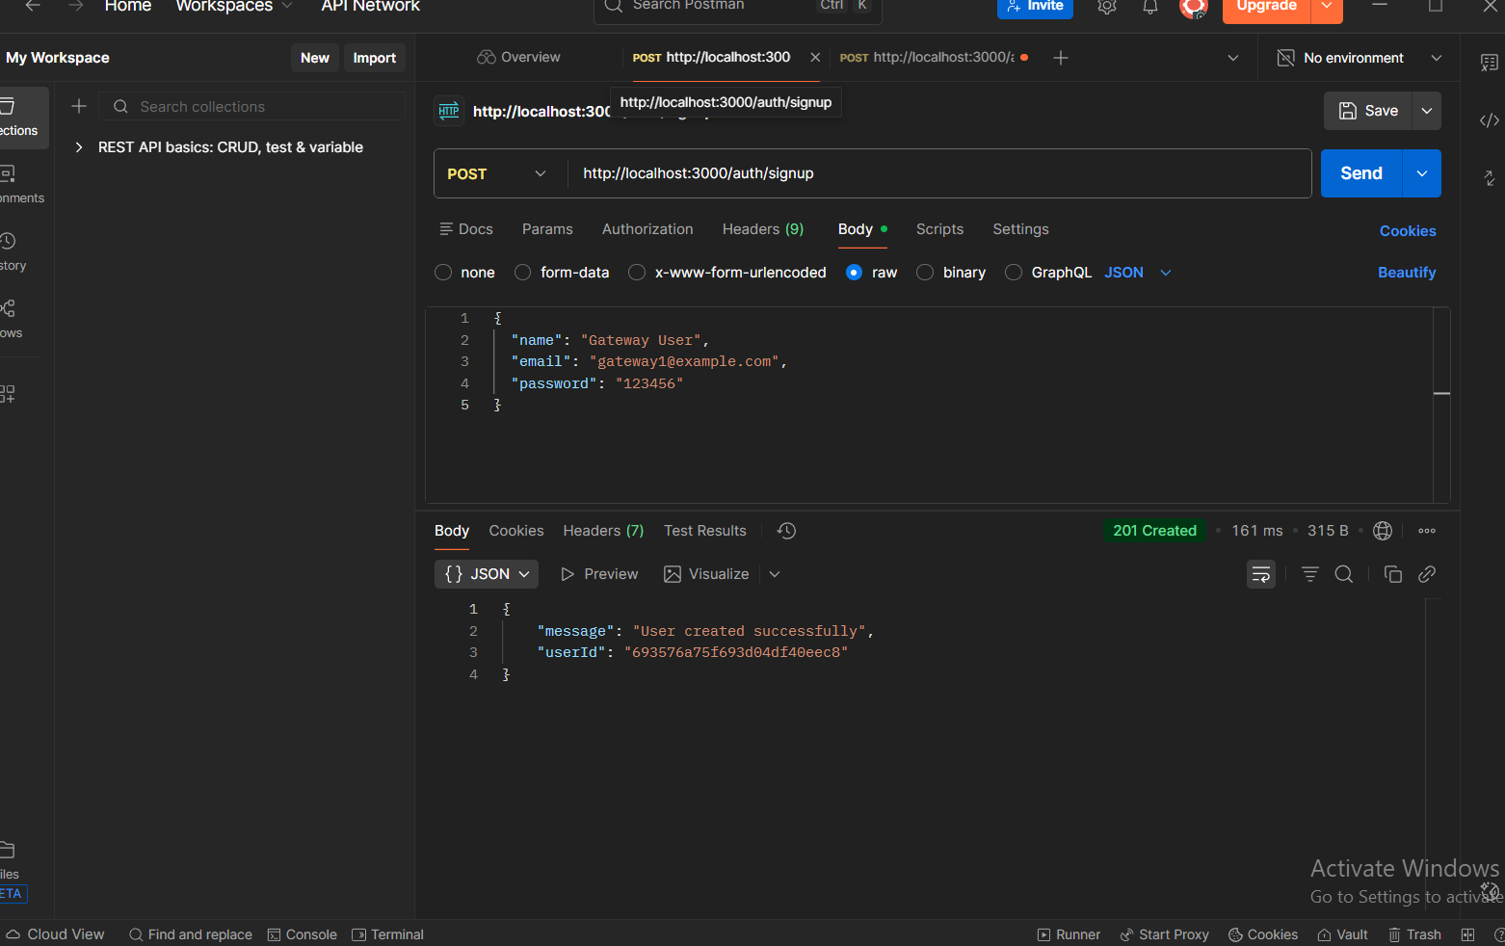
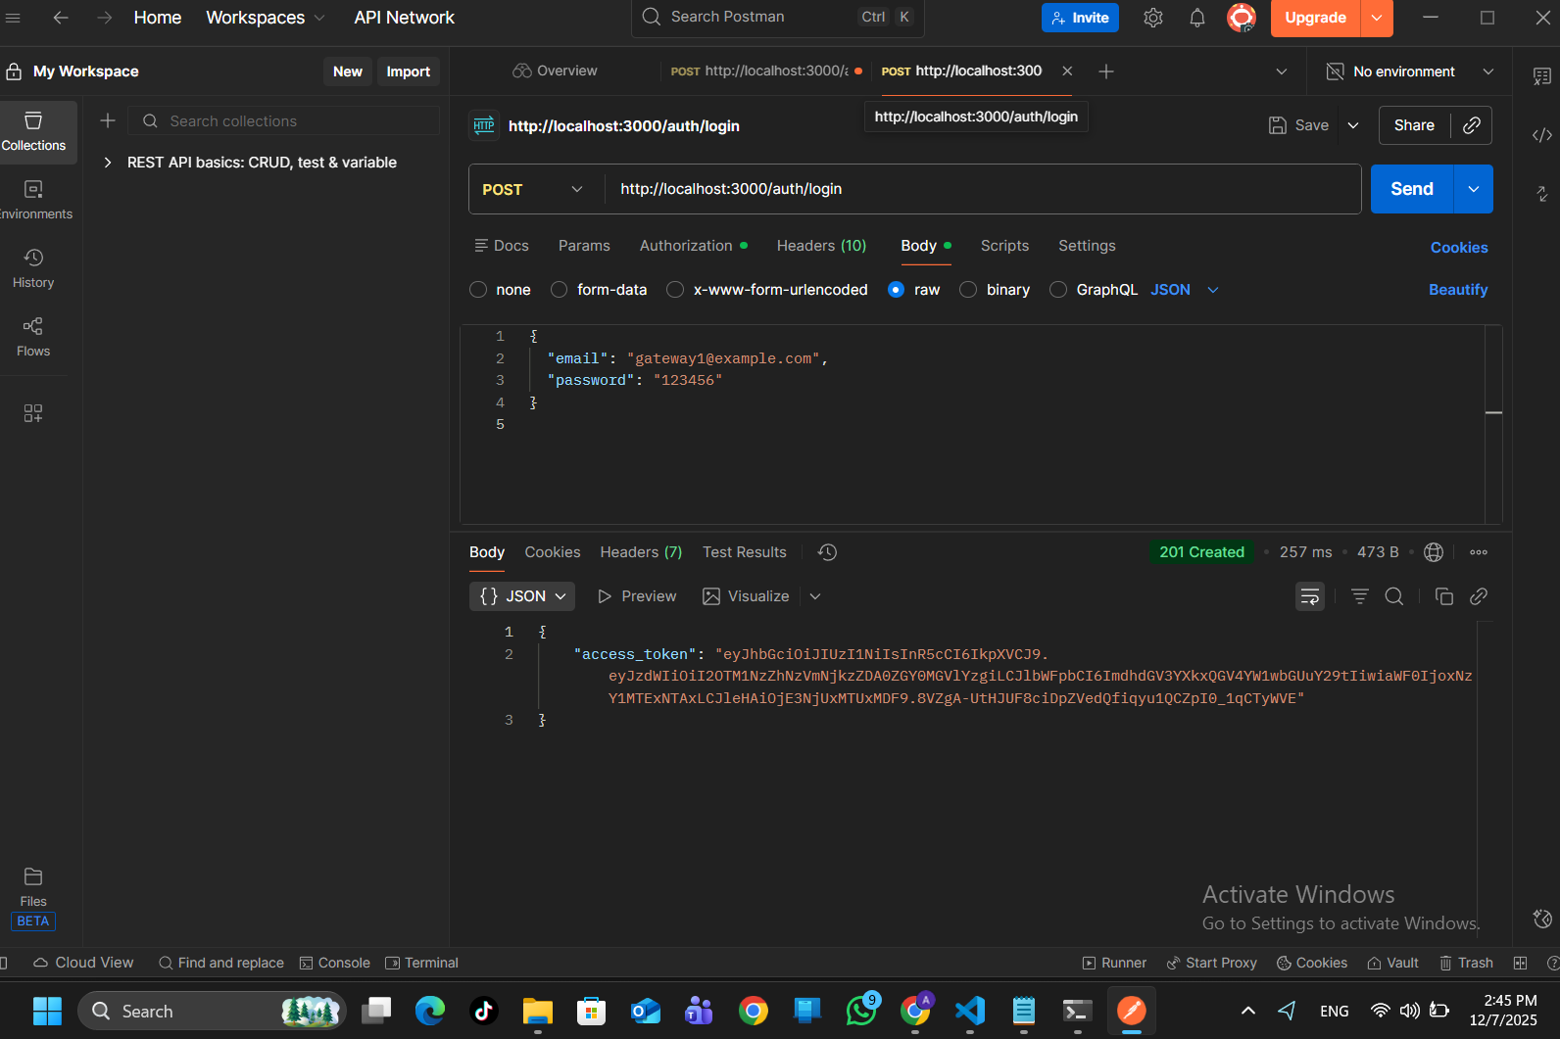

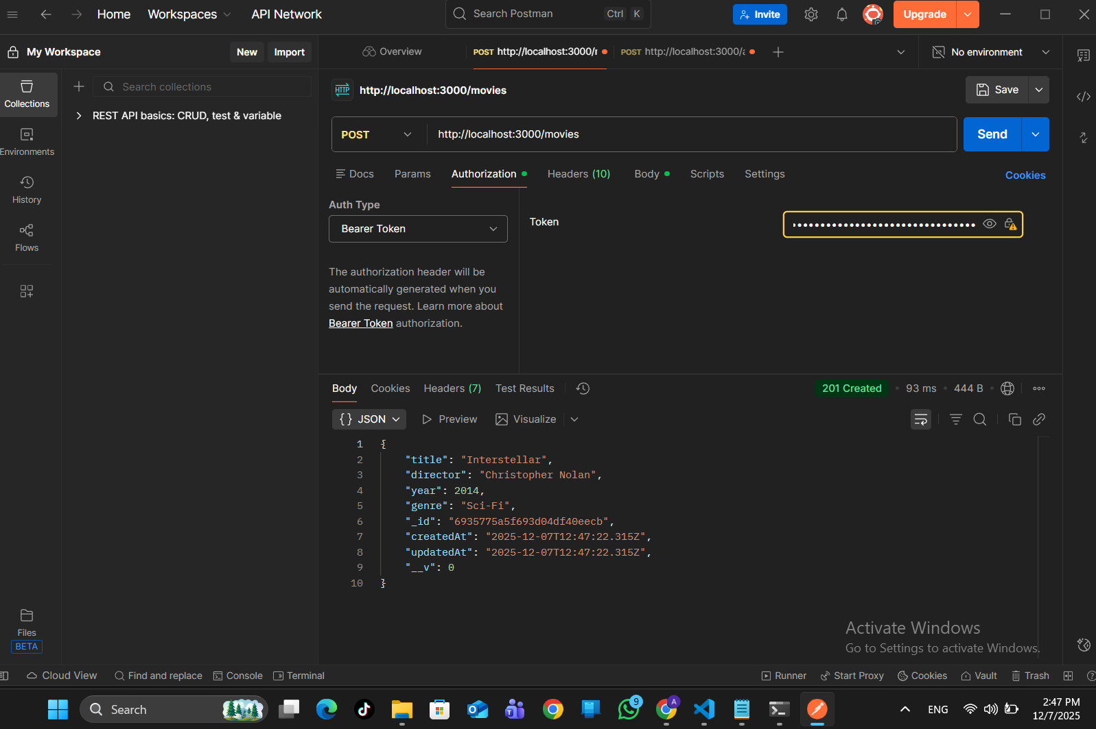
All API Gateway requests should reach microservices on port 3001, even though clients only interact with port 3000.

9. MongoDB Database Design and Implementation
MongoDB Atlas was used as the primary database for this microservices architecture. MongoDB is a NoSQL, document-oriented database, which stores data in flexible JSON-like structures called documents. This flexibility allows each microservice to manage its own collections independently, supporting the core microservices principle of database per service.
MongoDB Atlas provides several advantages essential for distributed systems:

• Cloud-based scalability
The database automatically scales to handle increased workloads without requiring server configuration.

• High availability and reliability
Replica sets ensure the system remains operational even if one node fails.

• Flexible schema design
Unlike SQL databases, MongoDB does not require a predefined schema. This supports rapid development and smooth integration with evolving microservices.

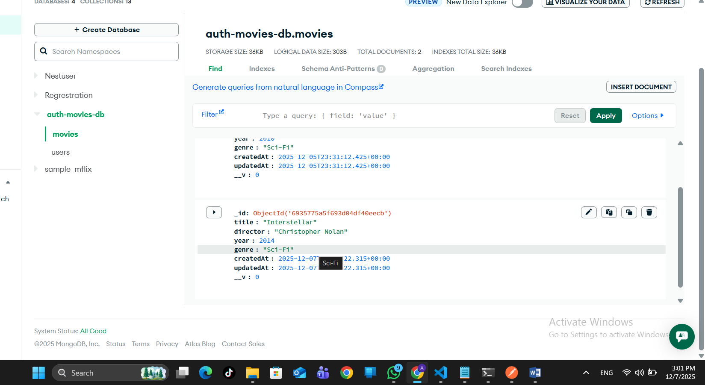

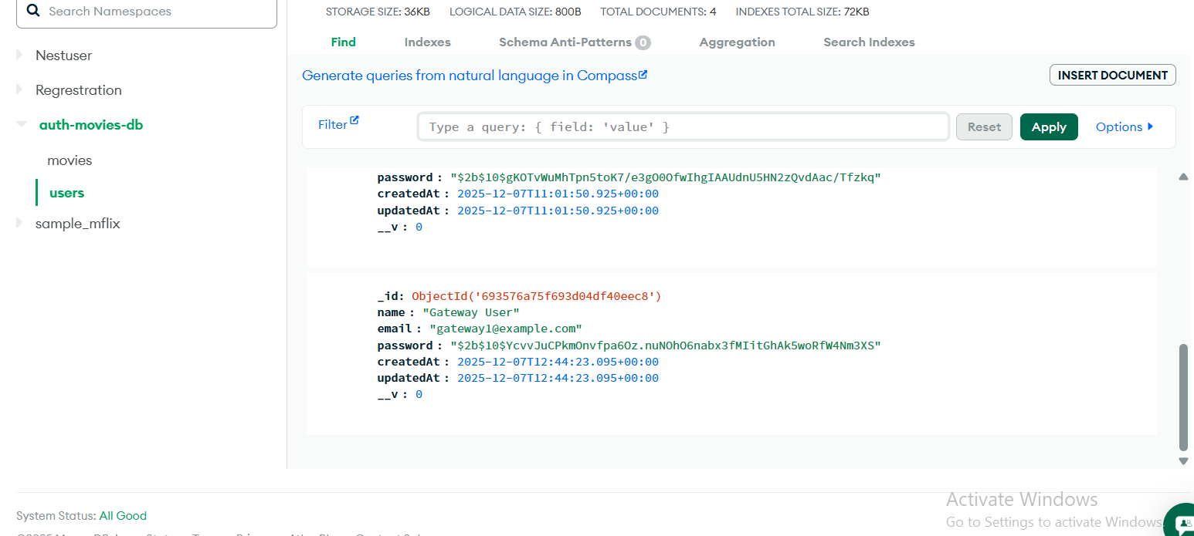

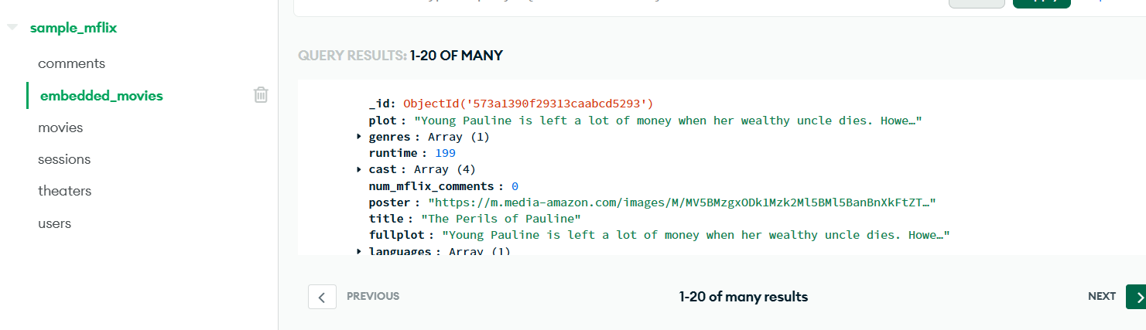

10. System Execution Instructions
To run the Authentication + Movies Microservice:
npm run start:dev

To run the API Gateway:
npm run start:dev

Microservices Run On:
http://localhost:3001

Gateway Runs On:
http://localhost:3000

11. Conclusion
This project demonstrates a real-world microservices architecture using NestJS, MongoDB Atlas, and JWT authentication.

Key achievements:
• Successfully built two independent microservices
• Implemented API Gateway for centralized communication
• Ensured secure authentication and authorization
• Developed complete CRUD operations
• Demonstrated full API testing with Postman

The architecture is scalable, modular, and follows modern backend engineering principles, making it ideal for enterprise‑level systems.

